Geometry: Unit 8, Lesson 6
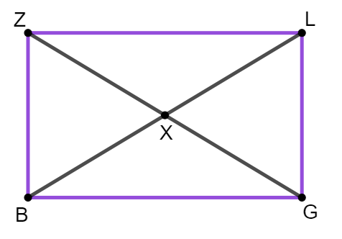
- Rectangle $ZLGB$ is shown where diagonals $\overline{ZG}$ and $\overline{LB}$ intersect at point $X$. $\overline{ZX}=6.5$, $\overline{ZL}=10$, and $\overline{ZB}=6$. What is the length of $\overline{BX}$?

$$\overline{BX}=6.5$$

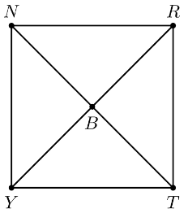
- Square $NRTY$ where diagonals $\overline{NT}$ and $\overline{RY}$ intersect at point $B$ and $\overline{NT}=25$ is shown. What is the length of $\overline{RB}$?

$$12.5$$
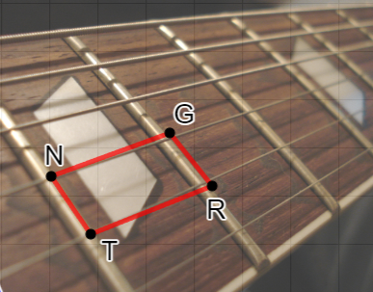
- The neck of a guitar consists of multiple parallelograms. Parallelogram $NGRT$ where $\overline{GR}=(4x+3)$ cm, $\overline{NG}=(2x+1)$ cm, and $\overline{RT}=\left(6x-3\right)$ cm is shown. What equation can be used to find the value of $x$?

$$2x+1=6x-3$$

